ECS Design including the Octagon as Control Device

I. Octagonal controls
The image below depicts one of six possible alignments of the user vis-à-vis the octahedron and the cube nested within. Four sectors are defined on the four faces of the octahedron. Clicking or pressing on one or the other of these faces are commands that cause particular things to happen, in the below case regarding “how?”. Things would work the same way for the other five faces.
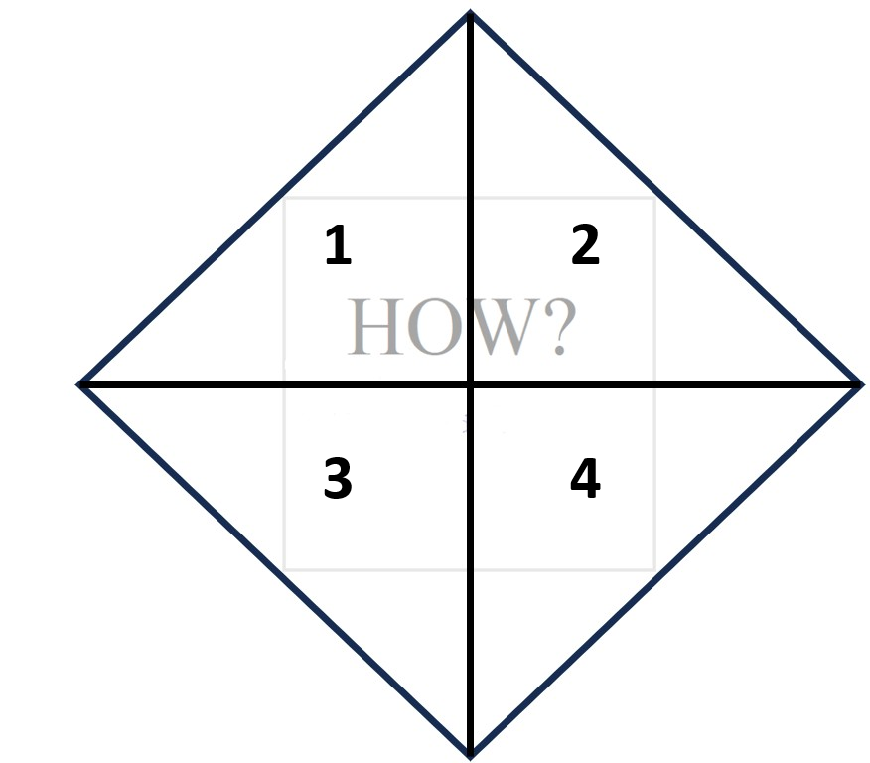

1. a. Long click: causes to appear long, read-only textual or corpus dimension description of how “how?” is being understood in this ECS (see visualization below); b: Long click takes the user to a lockable editable view of the long, read-only textual or corpus dimension of how “how?” is being understood in this ECS (note that what is lockable would be these texts/corpuses—it might be possible via a different permission to make additions [but not edits to existing texts] at this level) ; c. double-click: function still to be determined.
2. a. Brief click: causes to appear brief, read only (simple page-length dimension) description of how “how?” is being understood in this ECS (see visualization below); b: Long click takes the user to a lockable editable view of the brief, simple-page dimension description of how “how?” is being understood in this ECS (note that what is lockable would be these texts/corpuses—it might be possible via a different permission to make additions [but not edits to existing texts] at this level); c. double-click: function still to be determined.
3. a. Brief click: causes latest edits to be saved and an exportable log of all changes to the original ESC (in this case how?-specific changes) to be initiated; b. long click makes available two exportable AI-aided consistency checks: a) Are the long and short descriptions in this ECS internally consistent/do they contain any errors/contradictions?; b) Are the long and short descriptions externally consistent with an oppositional dynamic that distinguished it as instrumental vis-à-vis the manner in which “why” in this ECS is being defined as teleological; c. double-click: function still to be determined.
4. a. Brief click: clauses the ECS to be reset and again become turn-able or activatable via the activation button. b. long click & c. double-click: functions yet to be defined.
II. Editing Pages
Below is the possible look for the respective editing pages. In the above case of “How?”, the ECS consisting of octahedron and cube would remain in its place but faded out (like a watermark on a sheet of paper you can write on), and instead of the question “How?” you would faintly see its inverted (cubic) correspondent “Why?” on the “other” side of the cube.
Editing for how? and why? would use the 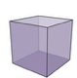 , for where and when the 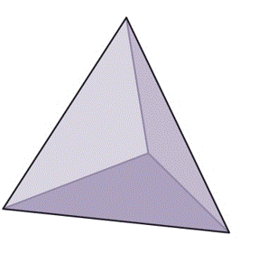 , and for who and what the inside the faded octahedral “watermark.”

Edits occur on a page looking something like this:

Headers: “HOW?—Genre/Corpus Dimension” or “HOW?—
Brief Descriptions/Questions-Dimension”
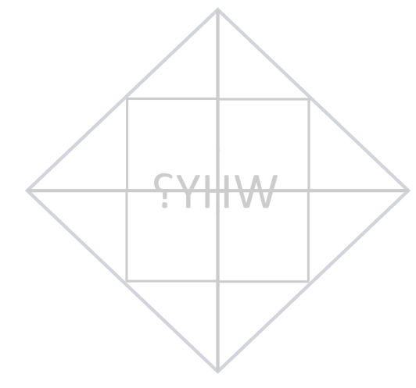

Link: return to ECS

III. Possible ECS homepage:

Import from AI  Import from ECS Assets  Import from  Grammar Cruncher  Import from Desktop | 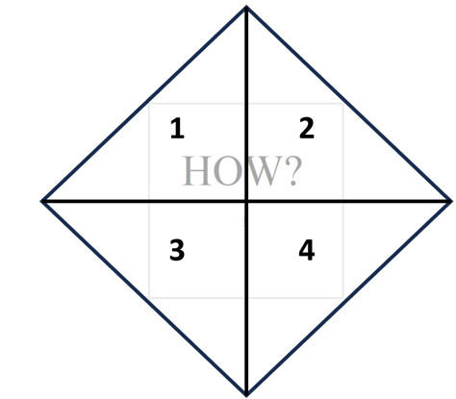  (The ECS is replaced here by the edit pages discussed above when edting.) | Button for activating the simulation:    Simulation would play here in this section & ECS to the left would spin truly according to “balance.”  (This view would be expandable to full screen, with little spinning ECS in a top corner).  Export Simulation & Log

IV. On gauging how “true” the simulation is, would it be possible to build these in to figure out the level of “wobble” when a given ECS is activated?
1. Vertical Consistency Gauge: Uses generative AI, via prompts set by managers/instructors, to set/gauge consistency of genre/corpus description level, brief descriptions/questions level, and the data that has been input.
2. Horizontal consistency Gauge: Uses generative AI, via prompts set by managers/instructors, to set/gauge consistency of genre/corpus descriptions, brief descriptions/questions, and/or input data across the 5W1H spectrum/spectra.
3. Completion Gauge: Uses AI to gauge the degree to which any criteria/questions made at the descriptions/questions level have been met as opposed to there being gaps.

